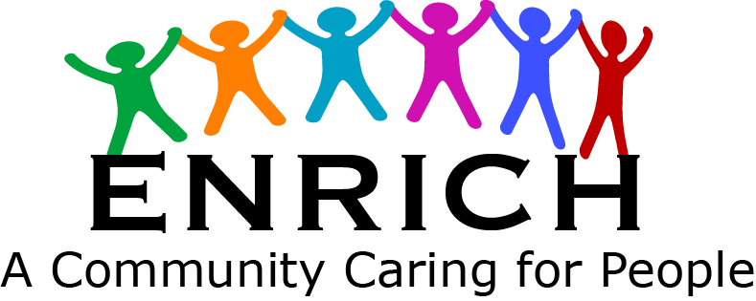

Community Circle Program
Item Request Form

Client Number________________ Intake Date________________

PLEASE PRINT CLEARLY

Name___________________________________ Phone:_____________ Alt. Phone_________________

Address________________________________________ City___________________ Zip____________

Applied before_______ When ____________________

Please list ALL household members:
Name ___APPLICANT____ Age_____ Name________________________ Age____

Name___________________ Age_____ Name________________________ Age____

Name___________________ Age_____ Name________________________ Age____
*************************************************************************************
Please check and quantity if more than one

___Twin Mattress

___Twin Box Spring

___Twin Frame

___Full Mattress

___Full Box Spring

___Full Frame

___Queen Mattress

___Queen Box Spring

___Queen Frame

___Couch

___Chair

___Loveseat

___Dining Set
(1 table + 4 chairs)

or

___Table Only

___Dining Chairs

___Refrigerator

___Electric Stove

___Gas Stove
Natural
Propane

Please Read and Initial:
Address must match ID. You must call in by the 10th of the month and let us know if you still need the requested items.
Clients may request items once in a 1 year period. All items are given out “as-is” without any guarantee as to working order. We will do our best to replace any large appliance that is given out that does not work, if reported within one week of receipt. If you sell any of the items given to you, you will be banned from getting assistance again.
Falsification of above information will result in removal from program.

Client Initial__________ Date________________ Staff Initial______________
DATA ENTRY
Boxed areas for Office use only:

CLOSED

FILLED

NEW

01/12rmj

